Technical Architecture:

Project Design Phase-II Technology Stack (Architecture & Stack)

|  |  |
| --- | --- |
| Date | 2 November 2022 |
| Team ID | PNT2022TMID49425 |
| Project Name | Smart Lender - Applicant Credibility Prediction for Loan Approval |
| Maximum Marks | 4 Marks |
| Team members | POOJA M  MOHANAPRIYA G  SIVASATHYA R  YUVARANI M |

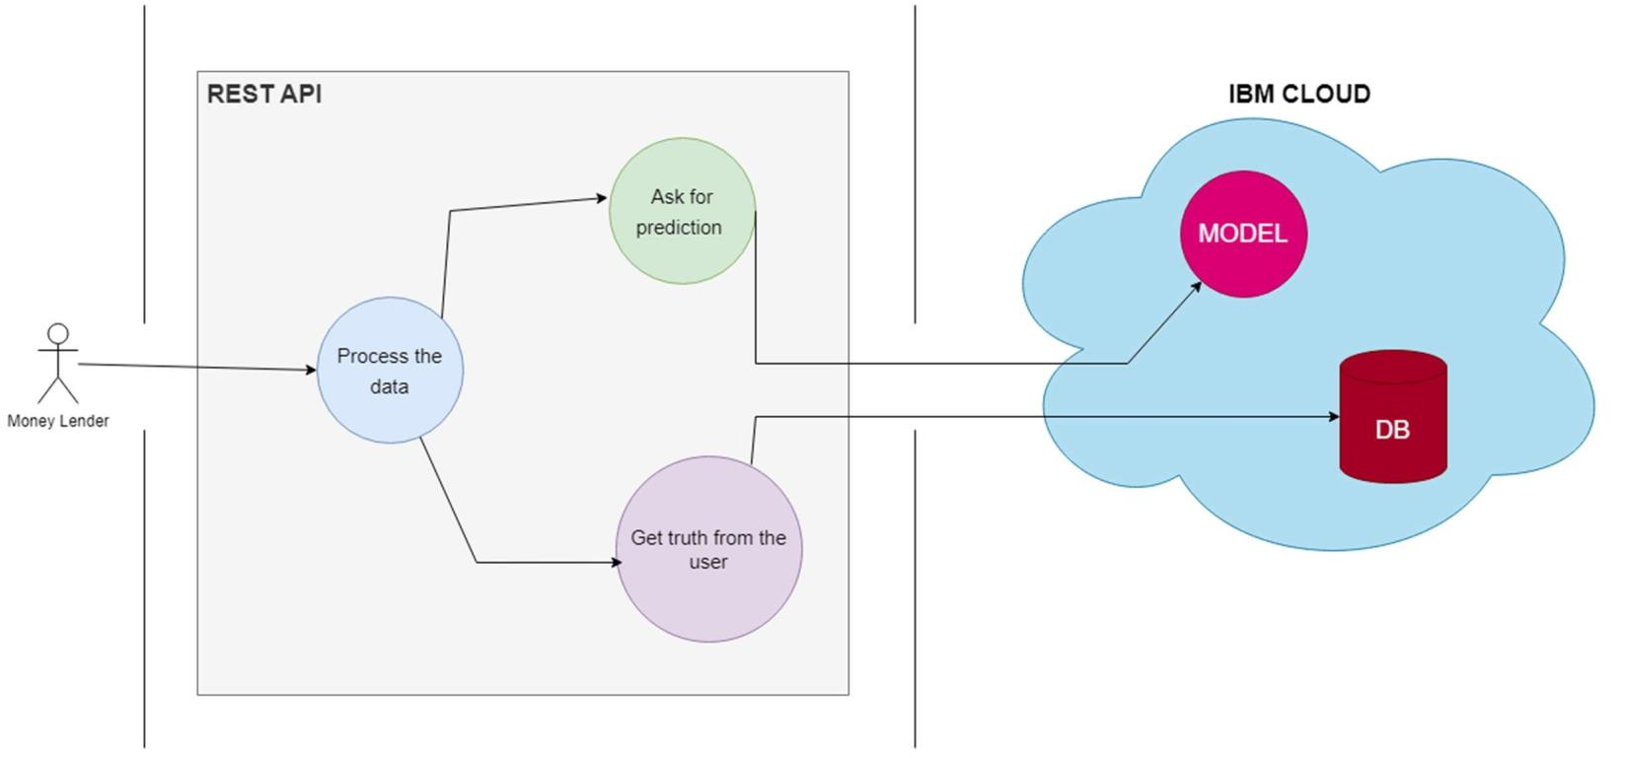

Table-1: Components & Technologies:

|  |  |  |  |
| --- | --- | --- | --- |
| S, No | Component | Description | Technology |
| 1. | User Interface | Web Application | JavaScript, React JS, React Styled Components, Tailwind CSS |
| 2. | Building User Application | Getting user information from the UI | JavaScript, ReactJS. |
| 3. | REST API | Processing the user information and sending it to the server | JavaScript, Node JS, Express JS |
| 4. | Chatbot | Handles basic queries of customer on loan approval | IBM Watson Assistant |
| 5. | Data Pre-processing and Visualization | Data Munging/Wrangling, Data Visualization and Analysis | NumPy, Pandas, -learn, Matplotlib, Seaborn |
| 6. | Cloud Database | Storing User information which could be used for further user analytics | IBM Cloud |
| 7. | Machine Learning Model | Prediction of borrower eligibility or  loan approval, approvable amount of loan | Cat Boost XG Boost, Decision Tree, Random Forest, KNN, Naive Bayes. |
| 8. | Infrastructure (Server / Cloud) | Application Deployment on Cloud for Platform-as-a- Service. | Cloud Foundry |

Table-2: Application Characteristics:

|  |  |  |  |
| --- | --- | --- | --- |
| S.No | Characteristics | Description | Technology |
| 1. | Open-Source Frameworks | ReactJS – framework for User Interface Tailwind CSS – utility-based CSS frameworks NodeJS – JS Runtime | ReactJS, Tailwind CSS, NodeJS |
| 2. | Scalable Architecture | MVC Architecture can be scaled on-demand Cloud Database – Model,  ReactJS – View,  NodeJS – Controller | IBM Cloud,  ReactJS, Tailwind CSS NodeJS |
| 3. | Availability | Application is available 24 / 7 as it is hosted on IBM cloud. Simple web browser is enough to access the website. | IBM Cloud |